**Class 07_12_2021**

**UG SEMESTER-3**

**Graph Theory**



**Theorem 1: A graph G is disconnected if and only if its vertex set V can be partitioned into two nonempty, disjoint subsets V1 and V2 such that there exists no edge in G whose one end vertex is in subset V1 and the other in subset V2.**

🡪 Let us consider a graph G(V,E) and V can be partitioned into two disjoint subsets V1 and V2 such that $V1∩V2=∅$ and V1 $∪V2=V$.

There exist no edge whose one end vertex is in V1 and other end vertex in V2. So there is no path that exist between any vertex of V1 and any vertex of V2. Hence G is disconnected.

To prove the converse, let us consider a disconnected graph G(V,E). So G(V,E) has two or more connected components.Let us consider a vertex u which belongs to one of the connected components. So we form a vertex set V1 which has a path from u, including u. we create another set of vertices V2=V-V1. Hence V1 $∩V2=∅$ also V1 $∪V2=$ V.

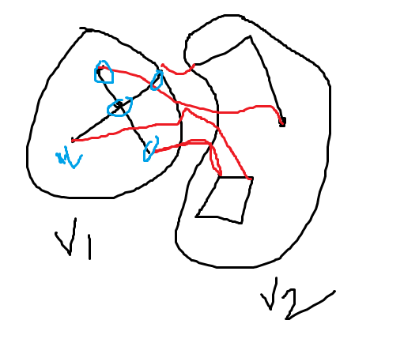

We take any arbitrary vertex u1 in V1.Now u and u1 has a path. If we take any arbitrary vertex u2 in V2 then u1 and u2 don’t have a path because if it exists then u and u2 would have a path through u1 and u2 would belong to V1. So there exists no path in between u1 and u2 i.e. no vertex of V1 has a path with any vertex of V2. Hence there is no edge exists whose one end vertex belongs to v1 and other end vertex in V2.

**THEOREM-2: If a graph (connected or disconnected) has exactly two vertices of odd degree, there must be a path joining these two vertices.**

🡪 Let us consider a graph G(V,E) where every vertex has even degree except two vertices say u1 and u2 whose degree is odd. Now we know that in a graph the number of odd degree vertices is even. This fact applies to each component of a disconnected graph. So each components must have odd degree vertex in even number if such vertices exists. Now as u1 and u2 are odd degree vertices hence they must belong to a single component. Hence there exists a path between u1 and u2.

Theorem: Prove that if a connected graph G is decomposed into two sub graphs g1 and g2, there must be at least one vertex common between g1 and g2.

🡪 Let us consider a graph G(V,E) which is decomposed into two sub graphs g1(V1,E1) and g2(V2,E2). Now g1 and g2 are edge disjoint. So E1 $∪E2=E and E1∩E2=∅$ $and V1∪V2=V$.*We have to show V1 $∩V2≠∅$.*

**Konisberg Bridge Problem**

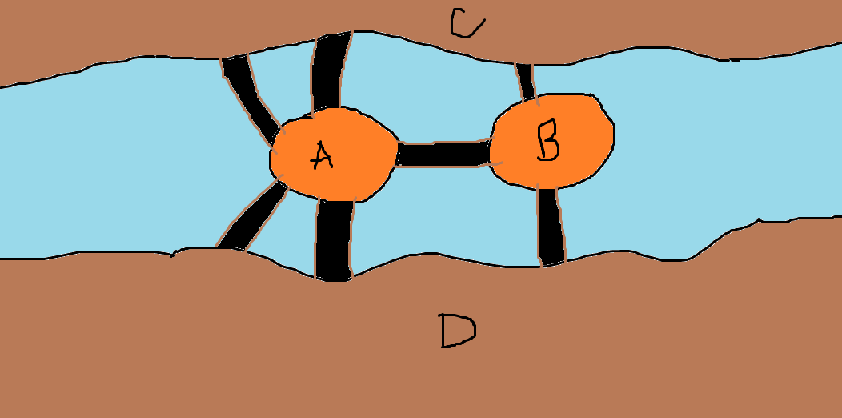

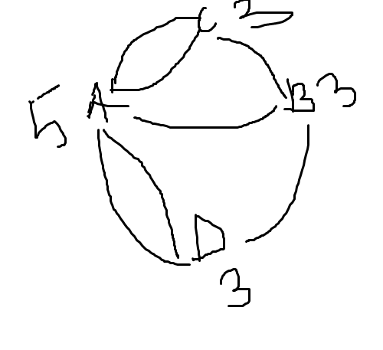

**Is it possible for a person to make a closed walk such that he/she traverses every bridge exactly once and would come back to the location where he/she has started walking?**

**The answer is a no…**

**Because if we convert the problem into a graph where the islands and banks are vertices and bridges are treated as edges of the graph then it is not an Euler graph.**

**Euler Graph: If in a graph G(V,E) we can draw an closed walk which covers all the edges of G exactly once, it is called an Euler line and the graph G containing the Euler line is called Euler graph.**

**In an Euler graph every vertex is of even degree.**

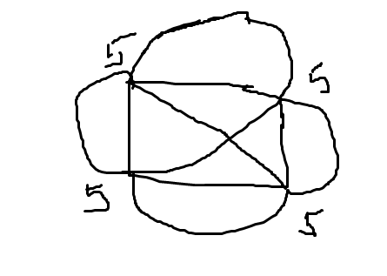

**In an Euler graph we can start from a vertex from which we can draw a closed walk which comes to the point where it has started and covering each edge of the graph exactly once. This closed walk is also called and Euler line.**

**Theorem: A connected graph G is Euler if and only if every vertex of G are of even degree.**